Newcastle Business School

The University of Newcastle

Course Code: BUSA3007

Course Title: Data Governance using Blockchain for Business

BLOCKCHAIN-BASED ESCROW SYSTEM FOR REAL ESTATE AND PROPERTY OWNERSHIP TRANSFER

Group Member | Student ID | Email
Tan Thuy Linh Dao | c3425175 | c3425175@uon.edu.au
Buu Quan Luu | c3422184 | c3422184@uon.edu.au
Qi Aun Heng | C3414272 | c3414272@uon.edu.au

Date Submitted: 19/10/2025

Word Count: max. 2400-word max.

(Excluding table of contents, table of figures, headings, sub-headings, references)

TABLE OF CONTENTS
TABLE OF TABLES 2
Abstract 3
1. Introduction 4
2. Background 4
3. Methodology 5
3.1. System Design 5
3.2. System Components 6
3.3. Data Governance Integration 7
3.4. Testing setup 7
4. Evaluation 8
4.1. System performance 8
4.2. Security evaluation 8
4.3. Data governance outcomes 9
5. Discussion 10
Reference 11

TABLE OF FIGURES
Figure 1. The structure of blockchain (Adilieme et al., 2025) 4
Figure 2. The flowchart of blockchain-based escrow system 6
Figure 3. The testing result of escrow smart contract 8
Figure 4. Account balance in Ganache after transfering ETH 8

TABLE OF TABLES
Table 1. A comparison table between traditional vs blockchain escrow (Michael, 2025) 9

Abstract

Currently, property rights transfer is subject to weak, centralised registries that are run by state actors, which forces transactions to follow a chain of intermediaries- that is, banks, agents and legal practitioners. These procedures frequently lead to difficulties and fraud in ownership validation due to their inefficiencies, inaccurate document management, misconduct issues, and lack of transparency. The report proposes a blockchain-based escrow system to improve efficiency, transparency, and trust in real estate transactions. The system uses distributed databases and smart contracts on the Ethereum network to automate verification, payment, and title transfer procedures. The system ensures data integrity, reduces fraud, and eliminates deed duplication.

Using Hardhat, we built and implemented a Solidity smart contract that makes the secure escrow mechanism automated and will only disburse payments once a verifiable land enforcer is contacted. It takes the form of transfer of ownership only upon completion of all the contractual prerequisites. The relative review of blockchain-based escrow interventions as compared to traditional registry procedures shows that both modalities will decrease human error, cut administration costs, and expedite the use of transactions. These results highlight the disruptive potential of blockchain technology in revolutionising digital governance of ownership of land, hence creating opportunities for internationally well-developed, cross-operable, and real-time property transfer system.

Introduction

Currently, property ownership transfer is a complex and paper-intensive process in real-estate transactions, requiring intermediaries like lawyers, conveyancers, notaries, and government registries. This system leads to negative consequences like processing time, administrative fees, and vulnerability to fraud and corruption (Munoz-Ausecha et al., 2023). Therefore, a conventional data governance structure is needed to maintain public trust and ensure legitimate ownership rights.

In this case study, the effective data governance used is a blockchain-based system offering new paradigms. This blockchain’s decentralised ledger provides trust, transparency, and cryptographic security, allowing all parties to verify data integrity without depending on a single central authority, as the unique feature of smart contracts in blockchain records all transactions in a block, hashed and added to the blockchain as an immutable block (Zarrin, 2021; Adilieme et al., 2025).

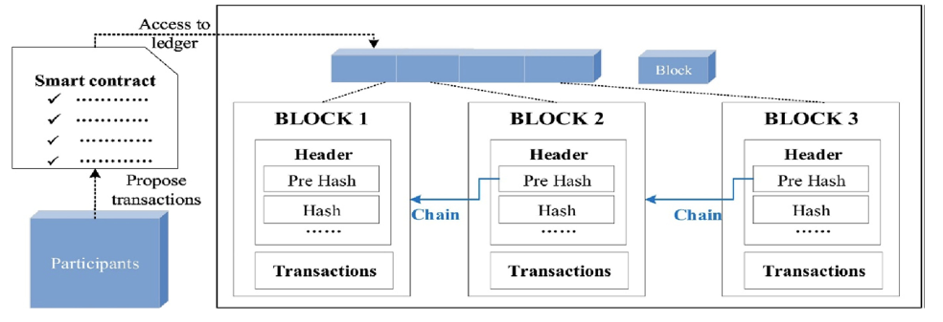
Figure 1. The structure of blockchain (Adilieme et al., 2025)
This paper addresses these inefficiencies by conducting a blockchain-based solution for secure property ownership transfer. Firstly, this report goes through the background context to identify the recent situation of the property area within Australia. Then, in this blockchain process of the implementation, it is first needed to create Non-Fungible Tokens (NFTs), ensuring uniqueness and traceability for the properties when performing the transactions. After that, combined with another smart contract representing the property sales flow, this enables automated and condition-based ownership transfer while maintaining high levels of encryption security and functional flexibility (Munoz-Ausecha et al., 2023). Finally, to allow user interaction, a web-based decentralised application is applied to showcase this blockchain’s application, facilitating communication between users and the blockchain network. Specifically, this web-based application uses the framework of ReactJS with MongoDB to store and manage data for web app architecture. Moreover, there is also the implementation of Webj3 to connect the backend (smart contract) to the frontend (web-based application).

Background

Although the transfer of ownership, the process of transferring property title in Australia, is governed by explicit laws, it is troubled by inefficiencies and high transaction costs because of the complexity of the legal and procedural requirements. Under the Torrens Title system, land ownership is governed by different laws in each state. However, the process usually includes negotiating agreements, title inspections, verification, settlement, and title registration, all of which frequently make for several middlemen (Cradduck, 2020).

The underlying issues still exist despite recent technological developments like e-Conveyancing, which enables online lodging through systems like PEXA. Digital payments optimised the payment settlement procedures. However, the risks of cybersecurity attacks and settlement fraud have caused big financial losses. Around 43 million in 2024, as compared to over AUD 13 millennium in 2021 (Devine, 2025).

Record-integrity issues also trespass classic property systems. Customers might be exposed, and systemic trust might be broken in case they lose possession to fraudulent title changes or forged records. Administration and necessary applications to realise a property owner by third parties reflect their requirement in the high costs of registering and servicing infrastructure.
The state and federal governments are looking for more inefficiencies through the technology blockchain. For example, reducing the requirement for paper-based signatures and improving verification transparency, the New South Wales Land Registry Services (LRS) started a blockchain proof-of-concept project that supports totally digital real estate transactions (Johnston, 2018). However, the Department of Planning, Transport, and Infrastructure (DPTI) of the South Australian Government has investigated several e-Conveyancing platforms and provides real-time ownership and deed verification (Otieno, 2019).

In a decentralised ledger, the blockchain may expedite approvals, automate ownership verification, and establish direct connections between buyers, sellers, and agents. This could speed up transaction settlement from weeks to hours, cut down on human interference, and remove needless contacts with government agencies (Potdar, n.d.).

The Digital Transformation Agency and the Australian PropTech industry are testing blockchain-based solutions for real-time settlements, property tax monitoring, and title registration, putting Australia real estate blockchain in globally. But there are challenges in the areas of connection with current Torrens Title registries and the legal acceptance of blockchain-based contracts, which constraints legislative frameworks that need to be changed before they can fully implement .

Methodology

System Design

The system is a self-executing computer-based contract that automatically implements the accepted condition between the buyer and seller without involving the middlemen. The smart contract is an escrow which contains the tokens of funds and property of the buyer and seller. Once the necessary conditions are met, i. e. the payment and ownership of the property are confirmed, the contract leads to automatic exchange: buyer obtains the ownership rights (in the form of tokens of property), and seller obtains the payment. In case of breach by either party, the contract safely refunds the money to buyer and repurchases the tokens to the seller. This decentralised mechanism provides reliable, non-trustful, safe, and non-modifiable transactions and complete visibility on the blockchain registry.
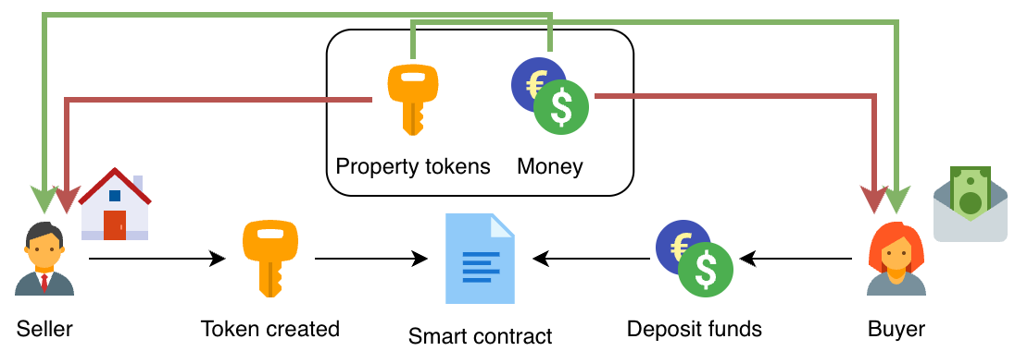
Figure 2. The flowchart of blockchain-based escrow system

System Components

Smart Contract (Solidity)

The logic of validation of the transactions, holding fund, and transfer of ownership is established in the smart contract written in Solidity. It outlines capabilities to deposit assets and check the terms of transactions and make exchange in case both parties agree. The mechanisms of reverting the transactions in case of failure to meet some of the conditions are also provided in the contract to avoid the occurrence of fraudulence and losses of the assets. The reason why solidity was selected was because it was compatible with Ethereum Virtual Machine (EVM) networks and had a strong ecosystem of decentralised applications (dApps).

Blockchain Network Connection (via RPC and MetaMask)

The contract is developed locally and tested on a blockchain network (Ganache) constructed as a simulation of an Ethereum-like environment to develop it. The blockchain and front-end application are connected through a Remote Procedure Call (RPC) URL. This enables the web-app to directly communicate with the blockchain to deploy a contract, execute a function, and recycle state. The decentralised application (dApp) is accessed with the help of MetaMask wallet allowing users to administer an account safely and interact with the blockchain. Every user, be it a buyer or a seller, links their MetaMask wallet to the application, which enables the contract to communicate with their digital assets. The wallet of the buyer holds the cash to buy the property, and the tokens of the property are in the wallet of the seller.

Web3 Front-End for User Interaction

The web interface is developed with ReactJS, allowing an interactive, user-friendly interface with the blockchain. The front end will be linked to the smart contract through the Web3.js library that helps users call contract operations, see property listings, make payments, and monitor the status of transactions in real time. When the users log in with MetaMask, the front-end loads the user account details as well as their wallet balance. The software will enable both sellers and buyers to have a seamless and intuitive experience at the highest level of transparency and security.

Data Governance Integration

Digital signatures and role-based access control (RBAC) are used to provide integrity and security of data. All transactions involve authentication using the user’s private key stored in MetaMask, which means non-repudiation and provides certainty that it is the legitimate parties performing the operations. The RBAC model differentiates buyers and sellers as roles, and functions are restricted by the level of authorisation. To take an example, the seller can only initiate a transfer of the property token, and the buyer can only authorise the release of funds. These control policies would guarantee that every action is inherent to the principles of the immutability of blockchain and protect user privacy and ownership of assets. The blockchain is a ledger of transactions that records the ownership of property permanently and provides an audit trail of property transfer that increases accountability and trust.

Testing setup

To ensure the functionality and reliability of the suggested smart contract system, a test was performed based on the Hardhat 3 development framework that offers a local Ethereum-like setting to compile, deploy, and simulate the blockchain transactions. There were two primary smart contracts that were deployed: PropertyDeed.sol and PropertyEscrow.sol.

The PropertyDeed.sol is a Solidity contract that is based on the ERC-721 standard, and it is the one that creates unique and non-fungible tokens (NFTs) representing the property title of an individual property. All tokens store their ownership data as a token ID and a URI, thus making every property asset traceable and verifiable on the blockchain.

The PropertyEscrow.sol contract is the central of the system, and it automates the logic of the escrows and transactions. It safely keeps the payment of the buyer and the property tokens of the seller till both agree on the set-out conditions of the contract. After the buyer and seller confirm the transaction, property deed token ownership is transferred to the buyer, and the money is automatically deposited to the seller. In case of failure of either condition, both assets are returned to the original owners of their possession, which is fair and trustless integrity.

To test it, the two contracts were deployed to the local Ganache network. The test reports in Ganache were related to MetaMask wallets where real-life interactions were simulated. The deployment logs confirmed that the property deed was minted with the address of the seller successfully and approved to be handled in escrow. The house was then sold at 1.0 ETH, the purchaser deposited the funds, and the deal was finalized between the two. This was completed automatically, giving the buyer the property deed (token ID #1) and pay the seller the money. The achieved output confirmed the fact that the smart contract process properly undertook all the state transitions- between listing, funding, and confirmation- without human intervention and third-party mediation.
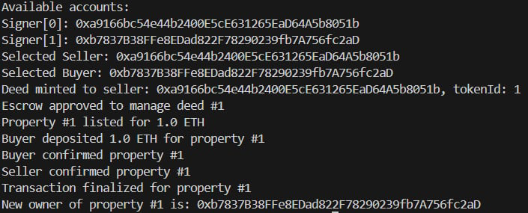
Figure 3. The testing result of escrow smart contract
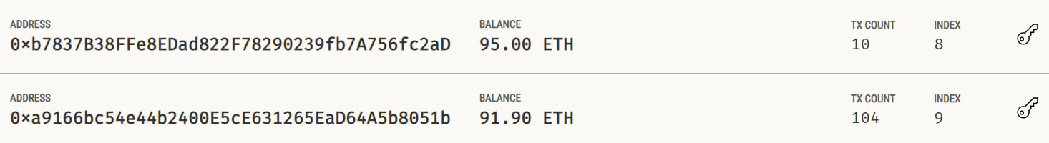
Figure 4. Account balance in Ganache after transfering ETH

Evaluation

System performance

Smart contracts reduce funds and property transfer times in weeks to minutes. However, the throughput and congestion of the underlying blockchain system remain the determinants of the real processing speed (Dabbagh et al., 2021). In comparison with Ethereum mainnet, other networks like Ganache allow faster and cheaper processes, which can expand scalability to a breadth of parallel transfer processes.

Blockchain escrow solutions remove intermediaries (banks and legal clerks) and significantly reduce the cost of transactions. With smart contracts, fewer administrative obligations are required by automating the settlement and verification. Despite the fact that operational costs, also known as petrol costs, continue to exist and vary with the activity of networks, the effect of the cost is minimised when compared to other public networks like Ethereum, with lower latency and enhanced cost-effectiveness (Dabbagh et al., 2021).

Scaling (Layer 2 and permissioned blockchains) solutions have potential opportunities to increase capacity to handle high transaction volumes, although current blockchain systems have throughput limitations (Dabbagh et al., 2021).

Security evaluation

Blockchain ledgers are immutable, and blockchain escrow solutions provide strong security features. Strong resistance against fraud and manipulation is provided by the cryptographic encryption of ownership records and transaction information once they are entered on the chain (Yli-Huumo et al.,2016). This immutability guarantees long-term trust and audibility of escrow transactions.

Unaudited smart contracts risk critical vulnerability, include re-entrancy, overflows and logic errors. To reduce these risks and preserve contract integrity, extensive testing, authorised verification, and security inspections must be put into place (Luu et al.,2016). Blockchain escrow solutions utilise identity authentication processes, including Know-Your-Customer (KYC) frameworks, role-based access controls and cryptographic digital signatures to improve security. These controls ensure only authorised individuals could transfer money or ownership.

Data governance outcomes

Stakeholders can evaluate and verify information through the immutable ledger of blockchain technology that transparently timestamps and dates record of all the transactions. This long history makes the transparency and reliability of property transactions minimise conflicts and promote trust among stakeholders (Databricks, n.d.).

The verification procedures that are automated due to the use of smart contracts do not require any manual checks that involve people. Data consistency and integrity make this automation reduce human error, speed up transactions, and lower the operating costs (Ovias, 2024).

The smart contracts encapsulate legal statutes and data governance standards under blockchain technology and ensure our compliance instantly. Cryptographic identities with role-based access controls ensure that people have access to or change data only when authorised. This promotes accountability and legal and regulatory requirements (Databricks, n.d.).

Table 1. A comparison table between traditional vs blockchain escrow (Michael, 2025)
 | Traditional Escrow | Blockchain-Based Escrow
Control | Centralised authority through reliable middlemen (banks, lawyers) | Decentralised, with not a single authority
Transparency | Limited transparency. manual and sometimes private documents | An unchangeable, transparent ledger that is open to the public
Security | easy targets for fraud, manipulation, and human error | Cryptographically secure, tamper-proof
Automated Processes | Manual processing and verification | Automated by smart contracts, reducing manual work
Speed | Delays from days to weeks due to manual steps and intermediaries | implementation almost immediately once requirements are satisfied
Cost | High fees due to intermediaries, administration, and delays | Lower transaction fees, no intermediaries
Dispute Resolution | Human involvement is required, but it may be expensive and slow. | Contract-based dispute resolution that is quicker and programmatic
Record Keeping and Audit | Frequent to loss and mistakes | Immutable, time-stamped audit trail
Scalability | Limited by manual human resources | Scalable through network protocols and automation

Discussion

In the process of transferring trust from human middlemen to system-enforced processes, blockchain technology radically changes data governance. Blockchain builds trust through decentralised cryptographic frameworks and unchangeable records that creating open and verifiable relations as opposed to trusting institutions and human validation (Liu et al., 2022). The transition will minimise reliance on potentially unreliable human actors and at the same time, increase openness, security, and accountability.

The unchanging quality of blockchain creates ethical and regulatory issues. For instance, it can be difficult to comply with laws like the General Data Protection Regulation (GDPR) since blockchain data is difficult to change or remove, which goes against rights like the "right to be forgotten" (Polcumpally et al., 2024). The problem of smart contracts also requires strict auditing and certified validation to avoid expensive errors. Furthermore, the access control implementation in decentralised environment requires complex cryptographic protocols besides maintaining privacy and transparency

The high implementation costs, uncertainty around the legal acceptance of smart contracts and blockchain records, and early user mistrust or distrust towards new technical systems represent several of the most common challenges (Liu et al., 2023). More straightforward governing laws, affordable scalability solutions, and user training initiatives to increase technological confidence are all necessary to overcome these challenges.

It is projected that in the future, there will be an improvement in compatibility of blockchain platforms with government-established land registries, thus leading to seamless transfer of data and impoition of statutory requirements. With the transaction pattern anomalies detected, cooperation with AI-based fraud detection engines can offer more sophisticated protection. Also, layer-2 scalability platforms will aim to decrease expenses and enhance transaction throughput to allow blockchain-based data governance to fulfil all larger adoptions and more complex procedural needs (Liu et al., 2023).

Reference

Adilieme, C. M., Abidoye, R. B., & Lee, C. L. (2025). Barriers and prospects for the adoption of blockchain technology in property valuation. Journal of European Real Estate Research., 18(1), 84–104. https://doi.org/10.1108/JERER-04-2024-0022

Cradduck, L. (2020). E-conveyancing: a consideration of its risks and rewards. Property Management, 38(1), 25-36. https://doi.org/10.1108/PM-04-2019-0021

Dabbagh, M., Choo, K. K. R., Beheshti, A., Tahir, M., & Safa, N. S. (2021). A survey of empirical performance evaluation of permissioned blockchain platforms: Challenges and opportunities. computers & security, 100, 102078.https://doi.org/10.1016/j.cose.2020.102078

Databrick. (n.d.). Data governance: A comprehensive guide to the processes, policies and tech that organizations use to manage and get the most from their data. https://www.databricks.com/discover/data-governance

Devine, A. (2025, August). Popular property scam on rise as nearly every Aussie fooled. Popular property scam on rise as nearly every Aussie fooled | news.com.au — Australia’s leading news site for latest headlines

Johnston, M. (2018, October). NSW keys blockchain for mandatory eConveyancing. https://www.itnews.com.au/news/nsw-keys-blockchain-for-mandatory-econveyancing-514016

Liu, Y., Lu, Q., Yu, G., Paik, H. Y., & Zhu, L. (2022). Defining blockchain governance principles: A comprehensive framework. Information systems, 109, 102090. https://doi.org/10.1016/j.is.2022.102090

Liu, Y., Lu, Q., Zhu, L., Paik, H. Y., & Staples, M. (2023). A systematic literature review on blockchain governance. Journal of Systems and Software, 197, 111576. https://doi.org/10.1016/j.jss.2022.111576

Luu, L., Chu, D. H., Olickel, H., Saxena, P., & Hobor, A. (2016, October). Making smart contracts smarter. In Proceedings of the 2016 ACM SIGSAC conference on computer and communications security (pp. 254-269).https://doi.org/10.1145/2976749.2978309

Michael, S. (2024, June). Blockchain vs traditional licensing: Comparison. ScoreDetect. https://www.scoredetect.com/blog/posts/blockchain-vs-traditional-licensing-comparison

Munoz-Ausecha, C., Gómez, J. E. G., Ruiz-Rosero, J., & Ramirez-Gonzalez, G. (2023). Asset ownership transfer and inventory using RFID UHF TAGS and ethereum blockchain NFTs. Electronics, 12(6), 1497. https://doi.org/10.3390/electronics12061497

Nicholas, O. (2019, October). Australian government explores the viability of blockchain for land and property conveyancing transactions. https://blockchain.news/news/australian-government-explores-the-viability-of-blockchain-for-land-and-property-conveyancing-transactions

Ovais. (2024, Apr). Blockchain technology and data governance: Enhancing security and trust.https://dev.to/ovaisnaseem/blockchain-technology-and-data-governance-enhancing-security-and-trust-ofb

Polcumpally, A. T., Pandey, K. K., Kumar, A., & Samadhiya, A. (2024). Blockchain governance and trust: A multi-sector thematic systematic review and exploration of future research directions. Heliyon, 10(12).

Yli-Huumo, J., Ko, D., Choi, S., Park, S., & Smolander, K. (2016). Where is current research on blockchain technology?—a systematic review. PloS one, 11(10), e0163477. https://doi.org/10.1371/journal.pone.0163477

Zarrin, J., Wen Phang, H., Babu Saheer, L., & Zarrin, B. (2021). Blockchain for decentralization of internet: prospects, trends, and challenges. Cluster Computing, 24(4), 2841-2866. https://doi.org/10.1007/s10586-021-03301-8

